LIGHT STEEL FRAME BUILDING



TECHNICAL COMMITTEE REPRESENTATION
The following organizations were represented on the Technical Committee:
Kenya Industrial Research and Development Institute
Space and Style Ltd.
Blackberry House Ltd.
Consumer Information Network
Edge & Atelier Ltd.
Kangemi Jua Kali Association
Edge & Atelier Ltd.
Kepsa/Kenya National Federation of Jua Kali
Sub County Health Services, Kamukunji
Dedan Kimathi University
Aluglass Ltd.
Mabati Rolling Mills Ltd.
Tile and Carpet Centre Ltd – Top frame Division
Zenith steel Fabricators-Light Frame Division
Kenya Bureau of Standards — Secretariat
REVISION OF KENYA STANDARDS
In order to keep abreast of progress in industry, Kenya Standards shall be regularly reviewed. Suggestions for improvements to published standards, addressed to the Managing Director, Kenya Bureau of Standards, are welcome.
© Kenya Bureau of Standards, 2022
Copyright. Users are reminded that by virtue of Section 25 of the Copyright Act, Cap. 130 of 2001 of the Laws of Kenya, copyright subsists in all Kenya Standards and except as provided under Section 25 of this Act, no Kenya Standard produced by Kenya Bureau of Standards may be reproduced, stored in a retrieval system in any form or transmitted by any means without prior permission in writing from the Managing Director.

LIGHT STEEL FRAME BUILDING

Kenya Bureau of Standards, Popo Road, Off Mombasa Road,
P.O. Box 54974 - 00200, Nairobi, Kenya
 | +254 020 6948000, + 254 722202137, + 254 734600471
 | info@kebs.org
 | @KEBS_ke
 | kenya bureau of standards (kebs)

Foreword
This Kenya Standard was prepared by the Construction Technology Technical Committee under the guidance of the Standards Projects Committee, and it is in accordance with the procedures of the Kenya Bureau of Standards
In development a lot was borrowed from SANS10162-2: The Structural Use of Steel Part 2: Limit-states design of cold-formed steelwork and SANS517: Light steel frame building
LIGHT STEEL FRAME BUILDING

1 Scope
This standard specifies requirements for fabrication and construction of buildings with light steel frames, clad and insulated with appropriate materials, including the roofs, walls, floors & foundations of such buildings.
This standard does not cover doors, windows, services, finishes or other elements of buildings that are either not peculiar to light steel frame buildings or do not have a direct interface with the steel frame.

2 Normative references
The following referenced documents referred to in the text in such a way that some or all of their content constitutes requirements of this document. For dated references, only the edition cited applies. For undated references, the latest edition of the referenced document (including any amendments) applies.

3 Terms and definitions
3.1 Definitions
For the purposes of this document, the following definitions and symbols apply.
3.1.1 Acceptable
Acceptable to the parties concluding the purchase contract, as relevant.
3.1.2 Acoustic Insulation
Insulation material installed to reduce the transmittance of sound from one side of the insulation to the other.
3.1.3 Air Infiltration
Air movement through a material, component or an assembly into a building
3.1.4 Roof Batten
Member fixed to roof trusses or rafters to support roof tiles OR ROOF SHEETS
3.1.5 Beam
Horizontal structural member that supports vertical loads and is subject to flexural stresses.
3.1.6 Bottom Wall Plate
Bottom plate: member running along the bottom of a wall frame and resting directly on a foundation wall, foundation beam or floor slab.
3.1.7 Bracing
Diagonal members, or diaphragms, that resist lateral movement of members or racking forces (or both).
3.1.8 Brandering
Member fixed to roof trusses or rafters to support the ceiling, and which does not apply to suspended ceilings
3.1.9 Brick Veneer
Single leaf non-load-bearing brick wall serving as exterior cladding.
3.1.10 Building Envelope
Exterior skin of a building, consisting of the floor, external walls, ceiling under roof overhangs, and roof cladding.
3.1.11 Bulk Insulation
Mineral or synthetic fibre wool in rolls which are available in different densities and thicknesses.
3.1.12 Chord
Top (rafter) or bottom member of a truss.
3.1.13 Competent Person
Person who is qualified, by virtue of his education, training, experience and contextual knowledge, to make a determination regarding the performance of a building or part thereof in relation to a functional regulation.
3.1.14 Domestic Dwelling
Building used for residential purposes, consisting of one or more dwelling units.
3.1.15 Energy Efficiency
Measure of the minimisation of the need to use energy for heating and cooling of buildings.
3.1.16 Expansion Joint
Discontinuation between elements, such as wall panels, to allow for relative movement between
adjoining elements and to prevent stresses arising in the elements from such differential movements.
3.1.17 Exterior Wall
Wall forming part of the building envelope, and which is normally load-bearing.
3.1.18 External Wall Cladding
Weather resistant external skin of a building, fixed to the light steel frame.
3.1.19 External Wall Cladding
Weather resistant external skin of a building, fixed to the light steel frame.
3.1.20 Fibre Cement Board
Composite material made of cement, sand and cellulose or synthetic fibres (or both).
3.1.21 Fire Rating
Shortest period for which a building element or building component will comply with the
requirements for stability, integrity and insulation.
3.1.22 Fire Resistance
Ability of a composite floor, wall or ceiling assembly to remain stable when exposed to heat
generated by fire.
3.1.23 Glass Wool
Material made from glass, spun into fibre-like structure.
NOTE Available in different densities (kilogram per cubic metre) for use as insulation.
3.1.24 Gypsum Board
Board with a gypsum plaster core with an envelope of two layers of paper
NOTE Gypsum board can be specified to be fire resistant or water resistant.
3.1.25 Light Steel Frame Building
Buildings in which the load-bearing structure, comprising the wall framing, columns, beams, trusses, panels or any combination of these, consists of assemblies of thin-walled cold-formed steel sections
3.1.26 Lintel
Horizontal member in a wall frame spanning over an opening
3.1.27 Non-load-bearing Walls
Wall that is not required to carry gravity or wind loads
3.1.28 Non-load-Bearing Walls
Wall that is not required to carry gravity or wind loads
3.1.29 Open Web Joist
Parallel-chord truss that supports concentrated or distributed loads, such as floor joists, rafters in a roof and lintels.
3.1.30 Purlin
Member fixed to roof trusses or rafters to support roof tiles or sheeting. (roof battens)
3.1.31 Racking
In-plane distortion of a framing module such as a wall or a roof, involving movement of the top
relative to the bottom, in the plane of the module.
3.1.32 Reflective Insulation
Material with a reflective surface such as a reflective foil laminate capable of reducing radiant heat flow due to its high reflectivity and low emissivity.
3.1.33 R-value
Measure of resistance to heat flow of a material or composite element, including the effects of any air spaces or reflective surfaces (or both).
NOTE The higher the R-value, the better the ability of the material or composite element to resist the flow of heat through it. R -values are expressed using the units, m²·K/W.
3.1.34 Spacing
Unless otherwise specified, the centre-to-centre distance between studs, joists, bearers, trusses,
battens, purlins or other elements
3.1.35 Span
Unless otherwise specified, the centre-to-centre distance between the supports of a beam, truss,
joist, purlin, batten, rafter or roof.
3.1.36 Stone Wool
Material made from stone or slag, spun into fibre-like structure.
NOTE Available in different densities (expressed using the units, kg/m³) for use as insulation.
3.1.37 Structural Steel
All steel which forms part of the structure, including the roof construction, wall frame construction,
floor and ceiling supports.
3.1.38 Thermal Break
Air gap or layer of insulating material between two building components to reduce the transfer of
heat by conduction.
3.1.39 Thermal Efficiency
Ability of a composite building component or assembly (floor, wall, ceiling or roof) to resist heat
transfer.
3.1.40 Truss
Latticed frame supporting the roof and ceiling over the full width of the domestic dwelling.
3.1.41 Uncontrolled Air Flow
Unintended movement of air into or through a room or a building.
3.1.42 Weatherproofing
Measures taken to prevent the ingress of moisture and to minimise uncontrolled air flow.
3.1.43 Web Member
Element of a truss or open web joist other than the top and bottom chord.
3.1.44 Sheathing
rigid board fastened directly to the wall studs to provide support for exterior cladding material, to lend structural support to the light steel frame members or to enhance the insulation of exterior walls
3.1.45 wall tie
bracket or wire connecting brick veneer cladding to the steel frame
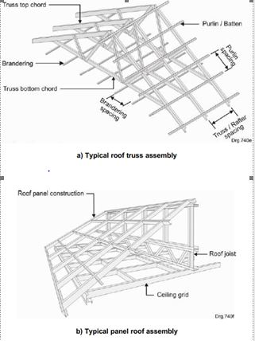
Figure 2 Typical Roof Assemblies

4 Symbols (and abbreviated terms)
A summed area supported by a structural member
cp resultant coeffici ent for internal and external wind pressure
cpe coefficient for external wind pressure
cpi coefficient for internal wind pressure
cr terrain roughness factor
d distance between points
G permanent load (own weight of building)
H height
L span or length
qk uniformly distributed imposed load
Qk concentrated imposed load
qp peak wind pressure
s spacing of elements
vb basic wind speed
w wind pressure
W wind load
Wr wind load on roof
Ww wind load on wall
W(down) downward-acting wind load
W(up) upward-acting wind load
A roof slope
Δ deflection
Ρ air density”.

5 Materials
5.1 General
Materials that have been proven to meet the requirements of the relevant standards, if used appropriately in combination with other materials, and installed to an acceptable quality of workmanship, are listed as being ‘acceptable’ in this section.
5.2 Steel
Cold formed steel, used for the structures of light steel frame buildings, shall comply with the requirements of an internationally recognised standard and shall have a coating at least equivalent in corrosion resistance and robustness to 150 g/m2 aluminium-zinc coating (AZ150) or 200g/m2 galvanizing (Z200) and AZ100.
Light structural steel members shall be manufactured using the prescribed steel strength grade (for example, 300 MPa or 550 MPa minimum yield strength) in accordance with the design specification
All steel used shall have sufficient formability to allow the cold forming of profiles without any cracking of the steel substrate.
Steel elements shall comply with the dimensional and straightness tolerances given in 5.3
5.3 Tolerances
5.3.1 Manufacturing and Assembly Tolerances
The tolerances for cold-formed sections are determined such that the relevant actual sectional properties differ by not more than ± 5 % from the design section properties.
The length of a component shall not deviate from its specified length by more than ± 2 mm.
A component that is specified to be straight, shall not deviate about any axis from a straight line drawn between the end points by more than L/1000 or 6.0 mm, whichever is less.
The height of assembled roof trusses may not deviate by more than ± 10 mm from the specified
dimension.
Assembled wall panels shall each not deviate from the specified dimension by more than:
Length: +2, -4 mm;
Height: ± 2 mm.
5.4 Fasteners
Carbon steel fasteners shall be coated with a zinc or inorganic coating (or both) to provide corrosion protection similar, under the prevailing conditions, to the metallic coated steel sheet used for the light steel cold-formed sections (for example coating designation AZ150).
Fasteners, connectors and fixing methods for the steel structure shall comply with the manufacturer’s recommendations, supported by international standards.
Steel components may be assembled by mechanical fasteners (such as bolts, rivets or screws). Assembly by other means (such as metal stitching and clinching) may also be used where suitable.
Where dissimilar metals are in contact, attention should be paid to insulation of the metals and the selection of suitable fasteners in order to inhibit galvanic corrosion.
5.5 Holding Down Devices
a) The materials for brackets and washers made from galvanised steel sheet, shall have a minimum coating designation AZ150 or Z200

6 Basis for Design
6.1.1 General
The structure shall resist all the loads the building will be subjected to, including loads deriving from its own mass. However, the lateral support provided to steel elements by the non-structural
elements of the building, such as the wall or roof cladding or the ceilings, may be taken into account in the design of these elements, provided that it can be demonstrated that the non-structural elements have adequate strength for lending such support, and that the steel structure will not be subjected to loads its elements cannot resist without such lateral support while the non-structural elements are, for whatever reason, not in position.
A clear path shall be discernable for every force, from where the force acts to the foundations, and all members and connections along this path shall have adequate strength and stiffness to resist the forces generated in them without failure, or deflections that exceed the maximum deflections specified in this standard.
6.1.2 Durability
The design criteria are based on the assumption that the materials used and their installation and maintenance will ensure that components fulfil their intended structural function for the intended life of the structure.
6.2 Resistances of Structural Elements and Connections
6.2.1 Design Standard
Cold-formed steel components shall be designed to meet the requirements of KEBS XXXXX
except where expressly specified differently in this standard.
6.2.2 Design Properties
The yield stress and ultimate strength of the steel shall, except for steel with a minimum yield stress of 550 MPa, be taken as the listed yield stress and ultimate tensile strength for that grade of steel in the applicable standard (see 5.2). The yield stress and ultimate strength of any steel for which the mechanical properties cannot be proved by means of a mill test certificate shall not be taken as higher than 200 MPa and 365 MPa, respectively.
Steel with a minimum yield stress of 550 MPa and of elongation less than 8 % may not be used in base metal thicknesses exceeding 0,90 mm. For such steel in base metal thicknesses of not less than 0,60 mm, the yield stress and tensile strength shall both be taken as 495 MPa, while for base metal thicknesses less than 0,60 mm the yield stress and tensile strength shall both be taken as 410 MPa.
The coated thickness of galvanised steel sheet may be referred to as the thickness of the sheet. As the coating does not add to the strength of the material, designers shall work with the base metal thickness as the thickness, determined as follows:
Bt = Ct - 0,04 mm
where
Bt is the base metal thickness, expressed in millimetres;
Ct is the coated metal thickness expressed in millimetres.
The dimensions of a steel section shall be taken as the specified dimensions, which shall be used
to derive the section properties.
Due allowance shall be made for holes, cutaways and other ways in which the strength of an
element may be impaired, including holes made during or after erection in the structure to
accommodate services.
6.3 Design Actions
6.3.1 General
Structural design actions and combinations of actions, in general, shall be in accordance with
KS XXXX. The simplified actions described in 6.3.2 to 6.3.4 (inclusive), may be used where
appropriate.
Construction loads may become critical on some components of an unfinished building and in such cases shall be accounted for in the design.
Where loads other than those specified in 6.3 (such as snow loads, seismic loads, or load
combination(s) containing such loads) are applicable, they shall be accounted for in the design.
6.3.2 Imposed Loads for Domestic Dwellings
For the design of domestic dwellings, the following characteristic imposed loads may be used, with the uniformly distributed load and the concentrated load not necessarily occurring simultaneously:
a) For roofs, not accessible except for normal maintenance:
Uniformly distributed load (qk): 0,5 kPa for contributory areas < 3 m²;
0,25 kPa for contributory areas >15 m2;
interpolate in-between;
Concentrated load (Qk): 1,0 kN applied anywhere.
b) For general floor areas:
Uniformly distributed load (qk): 1,5 kPa, but if the area A supported by a single column, wall, beam or girder exceeds 20 m2
q_{k} = {0,3 + 3,1} 1,5 ≥ 0,75 kPa
√A

Concentrated load (Qk): 1,5 kN.
c) Balconies and roofs used for floor type activities 1,0 m or more above ground:
Uniformly distributed load (qk): 4,0 kPa;
Concentrated load (Qk): 3,0 kN
d) Lateral horizontal loads applied to balustrades on balconies:
Uniformly distributed load: 0,5 kN/m applied at the top of the balustrade;
Concentrated load: 1,0 kN applied at the top of the balustrade.
6.3.3 Wind Loads
6.3.3.1 General
The wind loads used in the design of buildings meeting the geometric limitations of figure 1 may be calculated in accordance with 6.3.3.2 and 6.3.3.3.
6.3.3.2 Peak Wind Speed Pressure
The peak wind speed pressure qp expressed in kilopascals shall be determined using equation (1).
q_{p} = 1 .p (1,4 c_{r} v_{b0}) ²
2000

6.3.3.3 Wind Pressure on Surfaces
6.3.3.3.1 General
Wind load on structures and structural elements shall be determined taking into account the
simultaneous action of external and internal wind pressures.
The net pressure on a wall, roof or other element is the difference between the pressures on the
opposite surfaces taking due account of their signs. Pressure directed towards the surface is taken
as positive, and suction, directed away from the surface, is taken as negative.
6.3.3.3.2 Internal Wind Pressure
For a building without a wall with a dominant opening, the internal pressure coefficient cpi shall be taken as +0,2 or -0,3, whichever causes the more severe loading in combination with the
appropriate external wind pressure.
For a building with a dominant opening in the windward wall, the internal pressure coefficient cpi shall be taken as +0,75. If this dominant opening can be assumed to be closed during storm
conditions, the internal pressure coefficient cpi may be taken as +0,6.
A wall shall be regarded as containing a dominant opening if the area of its openings is at least
twice the sum of the area of openings and leakages in the remaining exterior walls of the building.
The wind pressure, w (expressed in kilopascals), on walls and ceilings in the building shall be
determined using equation (2) and the appropriate internal pressure coefficient cpi, as defined above.
w = qp.cpi
6.3.3.3.3 External Wind pressure on Walls
The external pressure coefficients cpe for buildings and parts of buildings depend on the size of the loaded area A, which is the tributary area of the structure that produces the wind action effect in the structural component to be calculated. The external pressure coefficients are given for loaded areas of 1 m2 and 10 m2 in the tables for the appropriate building configurations as cpe.1 , for local coefficients, and cpe,10, for overall coefficients, respectively.
Values for cpe.1 , are intended for the design of small elements and fixings with an area per element of 1 m2 or less, such as cladding or roofing elements. Values for cpe,10 may be used for the design of the overall load bearing structure of buildings.
The external wind pressure w (measured in kilopascal) on the vertical walls of the building shall be determined using equation (3) and the appropriate external pressure coefficients
we = qp.cpe
6.3.3.3.4 Resultant Wind Pressure
The resultant wind pressure w on walls or roofs is the sum of the internal and external wind
pressures, and shall be calculated using equation (4) and the appropriate internal and external
pressure coefficients
W = qp (Cpe + Cpi)
6.3.3.3.5 Wind Pressure on Roof Overhangs
The pressure on the underside of the roof overhang is equal to the pressure for the zone of the
vertical wall directly connected to the overhang; the pressure at the top side of the roof overhang is equal to the pressure of the zone, defined for the roof.
6.3.3.3.6 External Wind Pressure on Mono-pitch Roofs
The roof, including protruding parts, shall be divided into zones
6.3.3.3.7 External Wind Pressure on Duo-pitched Roofs
The roof, including protruding parts, shall be divided into zones
6.3.3.3.8 Local Wind Pressure at Corners of Roofs
The local external pressure coefficient for the square extending for 2 m in both directions horizontally from the corners of a roof shall be taken as -2,9. This pressure coefficient shall be used in conjunction with the pressure on the underside of the roof for the design of purlins, battens and sheeting and their fixings in this area.
6.3.4 Actions During Construction
Critical loads and combinations of loads during construction may be different from those for the
complete structure. These include:
a) Imposed load arising from the stacking of construction materials.
b) Imposed load arising from people working on the incomplete frame.
c) The wind load during construction may be based on a design wind speed with a mean return
period of 10 years. The wind load effects on the incomplete structure may be different from that
on the complete structure, for example, supported walls may become free standing walls during
construction, or roof sheeting in the internal zone of a roof could become edge sheeting, and
therefore need temporary bracing.
d) Unbalanced loads arising during construction.
e) Loads on roofs during construction:
uniformly distributed load (qk): 0,50 kPa for contributory areas <3,0 m2, or 0,25kPa for contributory areas ˃ 15 m2, with linear interpolation in-between.
6.4 Design Criteria
6.4.1 Strength and Stability
The building as a whole, and its parts, shall be designed to prevent overturning, uplift, sliding or
excessive settlement, as well as failure of either the steel elements or the non-structural materials
by collapse, tearing, unacceptable cracking or local deformations.
The design load for the ultimate limit state shall be that combination of (factored) loads which
produce the most adverse effect on the building.
6.4.2 Serviceability
The design criteria for serviceability shall be taken from, but not limited to, the criteria given in
sections 6.6 to 6.8 (inclusive).
6.5 Methods of Assessment of Resistances
6.5.1 General
The assessment of the resistance to loads of a structural element or structural assembly shall be
carried out by one of the following methods:
a) calculation;
b) testing; or
c) combination of calculation and testing.
6.6 Roof members
6.6.1 General
All roof roof members including purlins or roof battens, roof trusses or rafters, ceiling brandering and bracing shall be designed to act together as a structural unit to transfer all the loads imposed on the roof, including forces resulting from the fact that the roof provides lateral support to the walls under the action of wind load to appropriate supports.
6.6.2 Roof Battens and Purlins
6.6.2.1 Design for strength
The combinations used for the determination of the design load effects for strength are:
1,2 Gk + 1,6 Qk
1,2 Gk + 1,6 qk
0,9 Gk + 1,3 Wk(up)
1,2 Gk + 1,3 Wk(down)
6.6.2.2 Design for Serviceability
For satisfactory performance under each issue of concern, the calculated value of the serviceability parameter under the nominated load(s), shall be kept within the limiting value of the response.
6.6.3 Roof trusses or Rafters
6.6.3.1 Design for Strength
The combinations used for the determination of the design load effects for strength are:
1,2 Gk + 1,6 Qk
1,2 Gk + 1,6 qk
0,9 Gk + 1,3 Wk(up)
1,2 Gk + 1,3 Wk(down)
6.6.3.2 Design for Serviceability
For satisfactory performance under each issue of concern, the calculated value of each parameter
in the table below shall be kept within the limiting value of the response, under the action of the appropriate load.

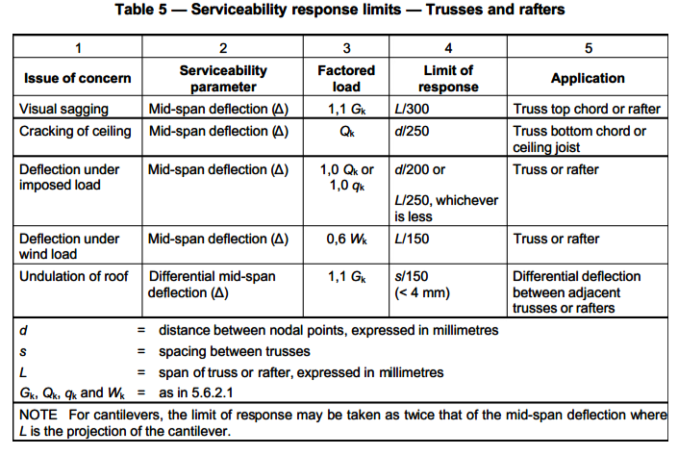
6.6.4 Ceiling Brandering
6.6.4.1 Design for strength
The load combinations used for the determination of the design load effects for strength are:
0,9 G_{k} + 1,3 W_{k(up)}
1,2 G_{k} + 1,3 W_{k(down)}
6.6.4.2 Design for Serviceability
For satisfactory performance under each issue of concern, the calculated value of the parameter
under the nominated load shall be kept within the limiting value of the response, as shown in the
table below.
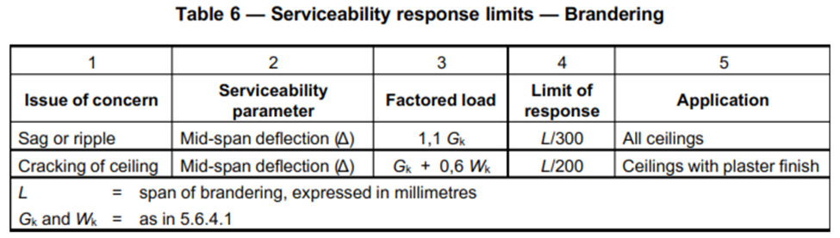
6.6.5 Roof Connections and Roof Bracing
Connections in the roof structure shall be designed in accordance with 6.6.6. Roof bracing shall be designed in accordance with 6.6.7
6.7. Connections
6.7.1 General
Connection elements include connection components (frame anchors, brackets, straps, plates,
parts of members to be connected) and connectors (welds, bolts, screws, rivets, clinches, nails,
structural adhesives).
6.7.2 Design Criteria
a) Connection elements shall be capable of resisting design load effects arising in the connection as the result of the design load effects in the connecting members and their supports.
b) Deformations at the connection shall be within the acceptable limits.
c) Appropriate allowance shall be made for any eccentricity at the connection.
d) Appropriate allowance shall be made for any local effects at the connections (for example, stress concentration and local buckling).
e) The uplift forces due to wind load shall be assessed and adequate tie-down shall be provided to resist these forces.
6.8 Bracing
6.8.1 General
Temporary bracing may be required during construction.
6.8.2 Roof Bracing
6.8.2.1 General
All roof members including roof battens or purlins, roof trusses or rafters, brandering and bracing shall be designed to act together as a structural unit to transfer all the loads imposed on the roof to appropriate supports. For lateral restraints, it is generally assumed that the roof battens or purlins will provide the lateral support for the top chords of the trusses and the ceiling brandering will provide the lateral support for the bottom chords of the trusses.
6.8.2.2 Truss Bracing
6.8.2.2.1 Top Chord Bracing
The requirement for a top chord bracing system is to transfer the forces generated in the top chord restraints (usually by battens or purlins) back to the supporting structures. The loads to be considered are those required to restrain the top chord against buckling.
Diagonal bracing shall be installed at an angle of between 30° and 60° to the truss top chord or
rafter, and it shall not sag more than 1/500 of the distance between supports. Where tension
devices are used to remove excessive sag, care shall be taken not to over-tension the braces.
6.8.2.2.2 Bottom Chord Bracing
Bottom chord bracing is required to restrain bottom chords against lateral buckling under wind uplift. It shall be fixed to each truss and to the wall in the same manner as for top chord bracing.
The loads to be considered are those required to restrain the bottom chord against buckling, which may be taken as equal to 0,02 times the maximum compressive force in the bottom chord, as well as wind load on walls supported at the bottom chord level.
A planar ceiling consisting of panels screwed to brandering, which is in turn screwed to the bottom chords of the trusses, may be regarded as providing adequate bracing to these chords.
6.8.2.2.3 Web Bracing
Where the truss design requires bracing of the web members, acceptable bracing, properly
supported and connected, shall be provided.
6.9 Testing
6.9.1 General
Tests of steel and steel elements or assemblies shall be carried out as specified in Ks xxxxx. The design resistance of an element, connection or assembly may alternatively be determined by testing. Only full size prototypes of an element, connection or assembly shall be used in tests.
6.9.2 Coefficient of Variation
The coefficient of variation of structural characteristics ( ksc), refers to the variability of the total population of the production units. This includes the total population variation due to fabrication (ksc)and material ( km). It can be approximated as follows:
ksc = √(kf2 + km²)
6.9.3 Establishment of Design Values for a Specific Product Using Prototype Testing
6.9.3.1 General
When the design resistance Rd, for a specific product is established by prototype testing of that
product the following conditions shall be satisfied:
a) the minimum number of tests shall be 3;
b) the design value Rd shall satisfy:
Rd ≤ (Rmin . lkt)
NOTE: The condition of the product under test should be the same as the condition of the product in use.
6.9.3.2 Interpolation of Values Obtained by Prototype Testing
When prototype testing is conducted for a range of a specific parameter (for example span), to
establish design values for a specific product in accordance with 6.9.3.1, it is permissible to
interpolate the obtained results for that parameter provided that there is no change in structural
behaviour (for example no change in collapse mode) within the interpolating range.
No extrapolation of test values is permitted.
6.10 Construction of the steel frame
6.10.1 Introduction
Buildings can be highly vulnerable during construction. An incomplete building is still required to be safe for the people on site. The actions that need to be taken depend on the method of construction.
6.10.2 Factors to be considered during construction
The following factors shall be considered:
a) The partially complete structure may be subjected to a variety of loadings
b) Regulatory safety requirements for workers in accordance with the relevant national legislation (see foreword).
c) Provision of scaffolding and barriers, particularly those that rely on the building frame for support.
d) Temporary bracing and tie-down during the installation of permanent bracing and tie-down.
Particular care should be taken to provide adequate temporary bracing for the lower storey of
multi-storey construction where racking loads are significantly higher than those in single storey
buildings.
6.11 Tolerances
6.11.1 Installation tolerances
6.11.1.1 Attachment to supporting structure
For load-bearing walls (including shear panels), gaps between the bottom plate and the concrete
slab greater than 3 mm shall be packed with load-bearing shims under each stud.
For non-load bearing walls, gaps greater than 3 mm shall be packed with load-bearing shims or grouted at jamb studs and points where the bottom plate is fastened to the slab. Where the gap under the bottom plate exceeds 10 mm the space between the bottom plate and the slab shall be filled with grout after installation of the shims.
For the attachment of floor joists, bearers, trusses and rafters to walls, where the gap exceeds
3 mm, the gap shall be packed with load-bearing shims.
6.11.1.2 Walls
Walls shall be positioned within 5 mm from their specified position.
Walls and studs shall not deviate from the vertical by more than h/600 or 3 mm, whichever is greater (where h is the height of the wall frame).
Walls, specified as straight, shall not deviate from a straight line by more than 5 mm over a
3 m length. Where wall panels join to form a continuous wall, the critical face or faces of the panel may not deviate by more than ± 2 mm at the joint.
The flatness of an individual wall that is to be lined shall be such that when a 1,8 m long straight
edge is placed parallel to the wall face, the maximum deviation from the straight edge does not
exceed 3 mm over 90 % of the area, and does not exceed 4 mm over the remaining area.
6.11.1.2 Trusses, Rafters, Ceiling Joists and Floor Members
Trusses, rafters, ceiling joists and floor members shall be positioned within 20 mm from their specified position.
Trusses, rafters, ceiling joists and floor members shall be installed so that they will not deviate from a straight line by more than L/500 where L is the length of the member
The difference in the level of points on adjacent members that are intended to be on the same level shall not exceed 1/150 of the spacing of the members or 6 mm, whichever is less.
Out of plumb at any point along the length of the truss from top to bottom, shall not exceed h/100 unless the trusses are specifically designed to be installed out of plumb
The flatness of the floor surface shall be within ± 10 mm over the entire room, but not exceeding
± 5 mm over any 3 m length, unless specifically designed with a slope. Abutting floors between
rooms shall be aligned, unless specifically designed otherwise.
When members such as joists, rafter trusses and structural wall studs (above or below a wall plate) are designed to be vertically aligned, the centre lines of the members shall not be more than 20 mm apart.
6.12 Durability and Corrosion
6.12.1 Steel Structure
Steel covered by wall or roof cladding, or surrounded by sub-floor walling, and not within 500 m of the sea, as well as steel that is not covered by cladding or surrounded by sub-floor walling, and not within 10 km of the sea or within a heavy industrial area, shall be continuous hot-dip galvanized sheeting with minimum coating class Z200, or a coating with corrosion resistance at least equivalent to 100 g/m2 galvanising, per side. An appropriate higher level of corrosion protection is required for steel structures located closer to the sea or within heavy industrially polluted areas.
Wherever galvanised steel has been welded or cut by flame, the affected areas shall be painted
with a zinc-rich paint having at least 85 % of zinc in the dry film.
6.12.2 Fasteners
6.12.2.1 The minimum specification for corrosion protection of fasteners is supplied in the table below:
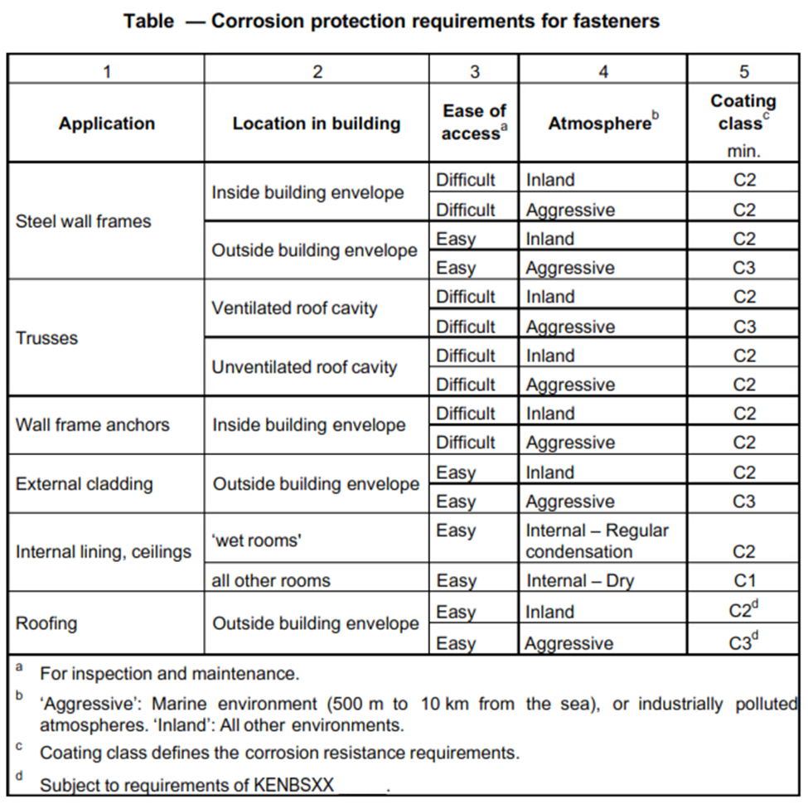
6.12.2.2 Test for compliance with coating class requirements: Screws shall be driven into a
galvanized sheet of at least 15 mm thickness, then removed and mounted on an inert material for
testing. The significant surface (i.e. head and un-driven shank) shall be evaluated. Salt fog tests
shall be made in accordance with KS xxxx, with an additional 240 hours of UV exposure before this for fasteners with organic coatings. The UV requirements shall be in accordance with ISO 11997-2, as follows:
a) Lamps and wavelength: UVB 313/280 nm
b) Cycle: 4 h UV/60 °C, 4 h condensation/50 °C
For C1 after exposure for 72 h, C2 after 240 h, and C3 after 1 000 h, no more than 5 % of the
significant exposed surface shall show red rust and there shall be no blistering of the coating.
6.12.2.3 Fasteners of the coating types in table below comply with the test requirements for the
respective coating classes.
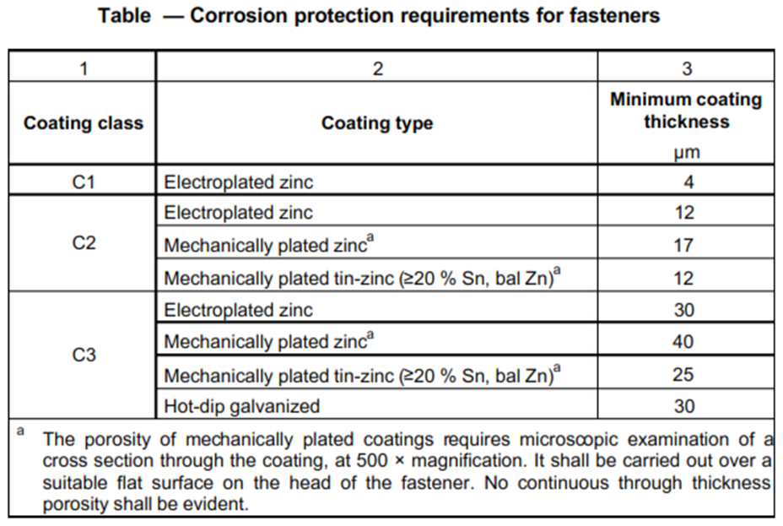
6.12.2.4 Fasteners not inside the building envelope and not washed by rain (for example under
overhangs) in marine and industrial environments, require additional protection against corrosion, such as organic coatings.
6.12.2.5 Fasteners or the packaging (or both) should be acceptably marked to show compliance.
6.12.2.6 Manufacturers of rivets should provide evidence that rivets, once installed, have durability required by the design, i.e. life expectancy equivalent to that of the materials being connected and compatibility with those materials.
6.13 Support of Wall Cupboards and Fittings
Noggings or other structural elements of sufficient strength shall be provided as required to support fittings such as kitchen cupboards or sanitary fittings and taps.
6.14 Earthing
The steel frame shall be properly electrically earthed to comply with KENBSXX ______.

7 Special Wall, Roofs and Suspended Floors
6.1 Scope
The requirements of this section cover the cladding, insulation, waterproofing and other materials attached to or installed between the elements of the steel frame. Windows, doors and other installations for ventilation such as, natural lighting are excluded. All buildings shall be designed to meet the requirements of the relevant national legislation for such buildings, and any additional applicable requirements.
6.2 General Requirements
6.2.1 Damp and Weatherproofing
Roofs, floors and external walls shall prevent the ingress of moisture from outside the building
envelope that can affect the health or comfort of occupants.
7.2.2 Durability
The building shall, with appropriate maintenance, be able to survive for its design life.
7.2.3 Energy Efficiency
7.2.3.1 General
The building shall facilitate, through its thermal performance, the efficient use of energy for artificial heating or cooling, while providing an acceptable indoor environment for its occupants or the processes conducted in the building.
A number of factors impact on the thermal efficiency of a building, such as roof colour, orientation of the building, area and type of glazing, shading for windows, sealing against uncontrolled air flow and insulation of walls, ceilings and floors. Only the limitation of uncontrolled air flow and insulation are addressed in this standard.
7.2.3.2 External walls
In order to meet the requirement of 7.2.3.1, the external walls of a domestic dwelling shall meet the thermal insulation requirements in the table below. Where a garage is attached to a domestic dwelling, either the outer wall of the garage, or the wall separating the garage from the domestic dwelling, shall meet the requirements in the table below.
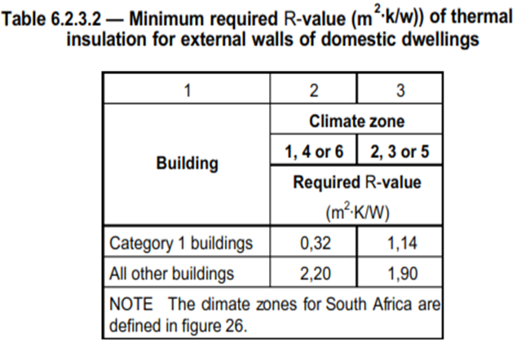
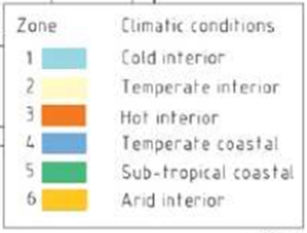
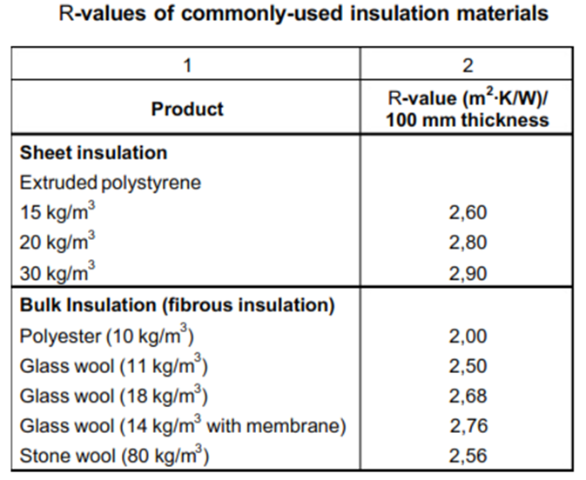
7.2.3.3 Roofs and Ceilings
The combination of roof and ceiling insulation of a domestic dwelling shall meet the thermal
insulation requirements in the table below.
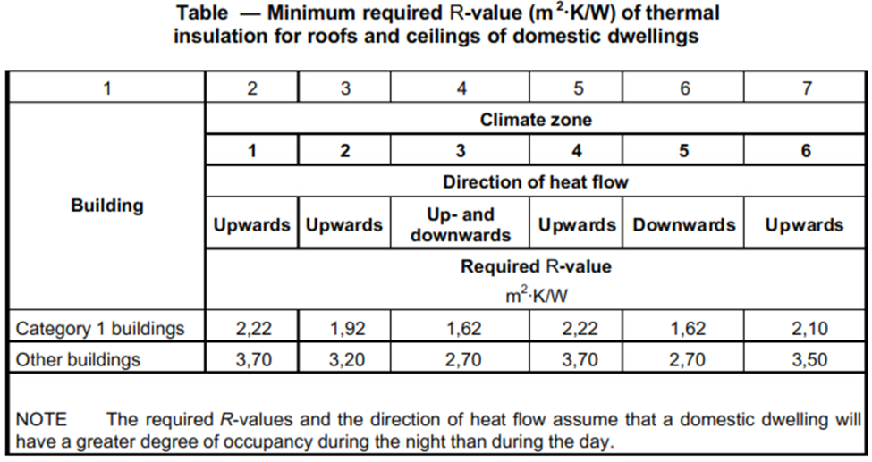
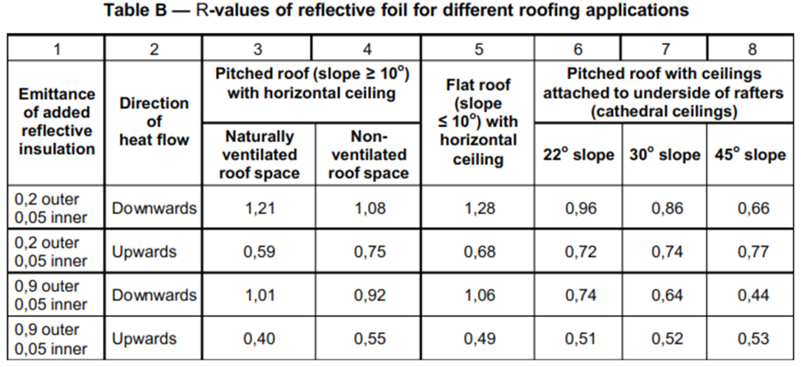
7.2.3.4 Floors
7.2.3.4.1 With the exception of climate zone 5, a concrete slab-on-ground shall have insulation
installed around the vertical edge of its perimeter which shall
a) have an R -value of not less than 1,0
b) be water resistant in order to retain its thermal insulation properties,
c) be continuous from the adjacent finished ground level
1) to a depth of not less than 300 mm, and
2) for the full depth of the vertical edge of the concrete slab-on-ground,
d) with an in-slab heating system, shall be insulated underneath the slab with insulation having a
R-value of not less than 1,0.
7.2.3.4.2 With the exception of climate zone 5, a suspended floor that is part of a building’s
envelope shall have insulation installed
a) for climate zones 1 and 2, with a partially or completely unenclosed exterior perimeter, which
shall achieve a R -value of 1,5.
b) for climate zones 3, 4 and 6, with a partially or completely unenclosed exterior perimeter, which shall achieve a R -value of 1,0.
c) with an in-slab heating system, around the vertical edge of its perimeter and underneath the slab, having a R -value of not less than 1,0.
d) The insulation shall be water resistant in order to retain its thermal insulation properties.
7.2.4 Acoustic insulation
The acoustic insulation in a building shall ensure that its occupants can use it for its normal
purposes without being unduly disturbed by noise coming from adjacent rooms or from outside, or being concerned that they may cause disturbance to people not in the same room.
The requirements for acoustic insulation for the walls of a domestic dwelling are contained in
the table below.
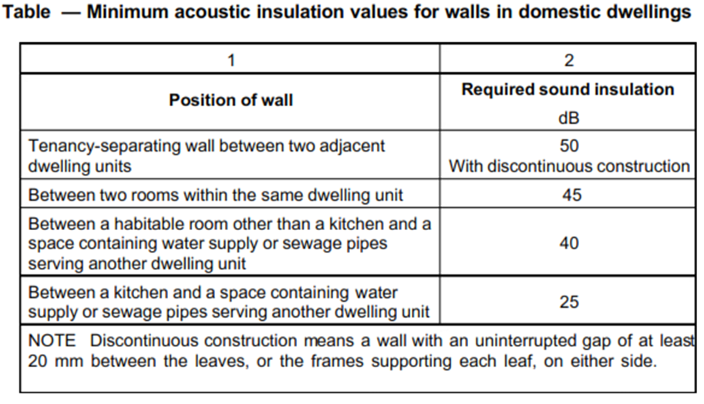
The acoustic insulation for floors between habitable rooms in domestic dwellings shall meet the
requirements in the table below.
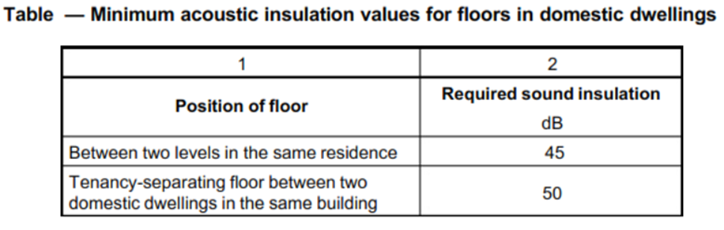
6.2.5 Fire Resistance
The required fire resistances of the elements of a domestic dwelling are given in the table below.
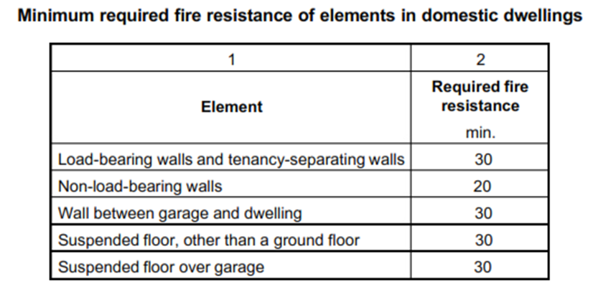
6.2.6 Air Infiltration
The uncontrolled movement of air through the shell of the building shall be minimized, to enhance the acoustic and thermal performance and energy efficiency of the building. Openings in walls such as for doors and windows, and abutments against ceilings and floors shall be sealed by caulking, and the use of sealants, skirtings, architraves and cornices.
6.2.7 Robustness
The fabric of the building shall be robust enough to survive deliberate or accidental impact of a
magnitude that could reasonably be expected, caused by human agents, animals or the weather,
with no or minimal damage.
6.3 Roofs and Ceilings
NOTE: The R -value of roofing insulation is obtained by adding the R -values of different insulation media together.
6.3.1 General Requirements
In an aggressive industrial or marine (within 10 km from the sea) environment, exposed parts of
trusses and purlins under the eaves shall be coated with an acceptable paint coating to enhance
the corrosion resistance of the galvanized sheet.
6.3.2 Deemed-to-satisfy Thermal Insulation Requirements
The table in 6.2.3.3 shows the minimum insulation requirements for roof-and-ceiling system for the various climate zones.
In regions 3 and 5 the required R-value of the thermal insulation may be reduced by 0,5 if the roof surface is light in colour, i.e. ranging from dull grey (weathered galvanised sheet) to cream and white.
6.3.3 Added Insulation
Required added insulation may be installed under the cladding or above the ceiling lining, (or both). See table A in 6.2.3.2 for R-values of different insulation materials.
If reflective foil is used, an air gap of at least 25 mm shall be maintained between the heat source
and the foil.
The R -values of reflective foil used in different roof or ceiling applications are provided in table B of 6.2.3.3.
6.3.4 Typical Construction Details
6.3.4.1 General
The typical construction details in 6.3.4.1 to 6.3.4.4 (inclusive), are deemed to satisfy the requirements given in 6.2, however, proof of compliance should be supplied by the material
manufacturers. Other methods and materials may be used, subject to proof of compliance with the requirements of 6.2.
6.3.4.2 Ceiling Linings
The R-value of roof and ceiling materials attached to the underside of rafters is as follows:
Metal cladding = 0,35 m2·K/W;
Cement/clay tiles = 0,37 m2·K/W.
The fire rating is 30 min.
The ceiling lining attached to the underside of rafters is shown in the figure below,
Ceiling lining attached to underside of rafters
The ceiling lining attached to the underside of battens or purlins is shown in the figure below.
Ceiling lining attached to underside of battens or purlins
6.3.4.3 Pitched Roof and Horizontal Ceilings
6.3.4.3.1 Ventilated Roof Spaces
The R -value of roofing materials for ventilated roof spaces (see figure below) is as follows:
Cement/clay tiles = 0,22 m².K/W;
Steel roof cladding = 0,20 m^{2.}K/W;
The fire rating is 30 min.
Pitched roof and horizontal ceiling — Ventilated roof space
NOTE: For added insulation options see the table below.
6.3.4.3.2 Unventilated Roof Spaces
The R-value of roofing materials for unventilated roof spaces (see figure below) is as follows:
Metal cladding = 0,38 m²·K/W;
Clay/concrete tiles (with underlay) = 0,40 m². K/W.
The fire rating is 30 min.
Pitched roof and horizontal ceiling – Unventilated roof space

8 Marking
Tags, paint, ink marks or other suitable means shall be used to identify members of unassembled components or parts. Erection marks that damage the material or finished surfaces exposed to view shall not be used. Each structural member shall be legibly marked with the following information:
a. The manufacturer’s name or trademark or both
b. The Batch identification
c. Thickness in mm
d. Coating designation
e. Manufacturer’s Standardization Mark (SM) permit number

ANNEXURE 1
(normative)
Roof Construction
A.1 Typical roof construction
The guide in table A.1 can be used for load calculations for typical roof construction.
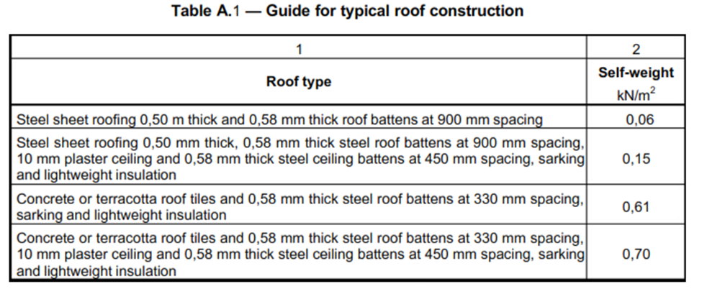
Typically, asphalt shingles should be fixed / stuck on top of water proofing applied to OSB or similar boards which are laid on top of the LGS roof battens.
Roof battens are spaced suitably for the boards (generally, 600mm c/cs for boards measuring 1.2m x 2.4m)

